Introduction
The Odoo Mobile Barcode App enables users to perform real-time warehouse operations using barcode scanning.
This manual specifically explains how to perform Inventory Count (Stock Adjustment) using the Barcode app to verify and adjust physical stock quantities.
Logging into the Barcode App
- Insall Odoo app from play store
- Open the Odoo mobile app.
- Enter your database URL.
- Login with your credentials.
- Select the Barcode app.

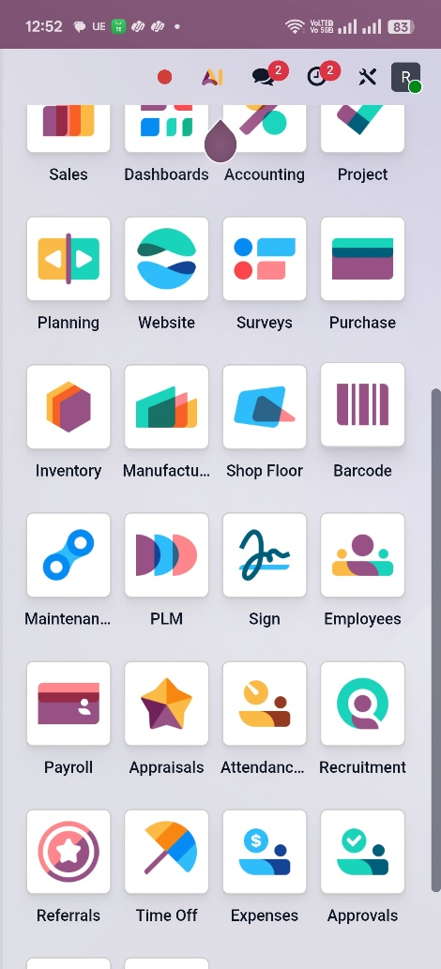

Inventory Count (Stock Adjustment)
Used for physical stock verification.
Steps:
- Open Barcode → Count Inventory.
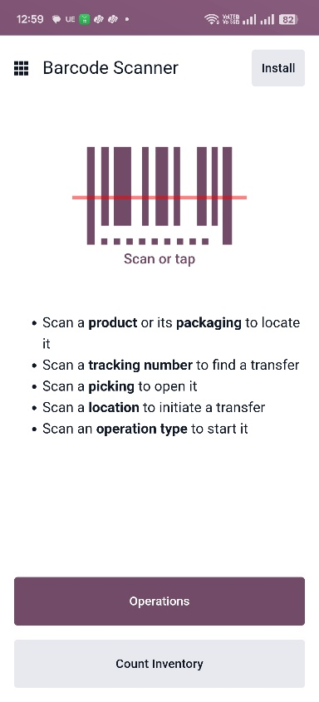
- Tap on the ⚙ Settings icon.
- Enable “Count Entire Locations” if performing a full warehouse count.
- Leave it disabled if adjusting only specific products.
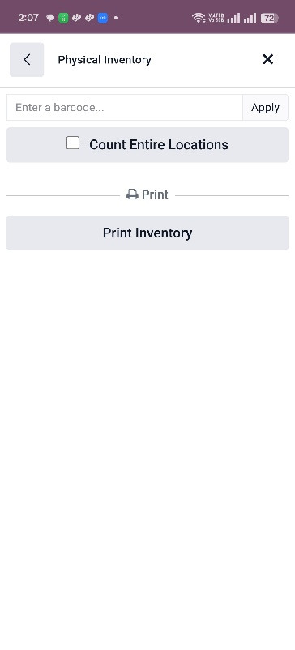

- Tap the barcode icon at the top to start scanning.
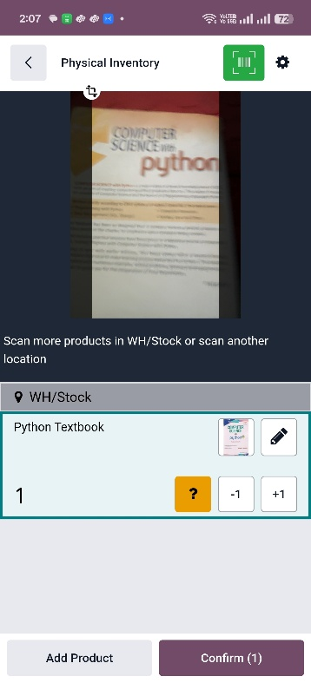
- Scan each product barcode to count it.
- You can also manually enter the quantity by tapping the pencil icon.
- Tap “Confirm”.
- In the confirmation pop-up, enter the inventory reason.
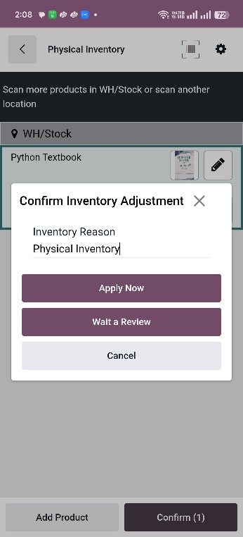
- Tap “Apply Now” to update the inventory count immediately.
- You can choose “Wait for Review” to submit inventory adjustment for approval.

